Equivalent Fractions
The fractions having the same value are called equivalent fractions. Their numerator and denominator can be different but, they represent the same part of a whole.
Consider the following:
1/2
Shaded to whole shape is half to whole i.e., ¹/₂
2/4
Shaded to whole shape is 2 to fourth i.e., ²/₄ = ¹/₂

4/8
Shaded to whole shape is 4 to eighth i.e., ⁴/₈ = ¹/₂
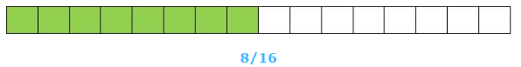
Shaded to whole shape is 8 to sixteenth i.e., ⁸/₁₆ = ^{½}
So, 1/2, 2/4, 4/8, 8/16 are equivalent fractions.

Building Equivalent Fractions:
1. Change 2/5 to an equivalent fraction with denominator 15.
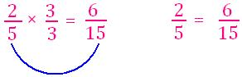

Multiply numerator and denominator by the same number to get the required denominator.
2. Change 9/12 to an equivalent fraction with denominator 4.
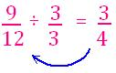
To find an equivalent fraction with smaller denominator, you can divide the numerator and denominator with the same number.
3. We can build equivalent fraction with multiples of numerator and denominator.
Write the next three equivalent fractions.
